Requiem - Easy Read

 | What happens in Requiem?
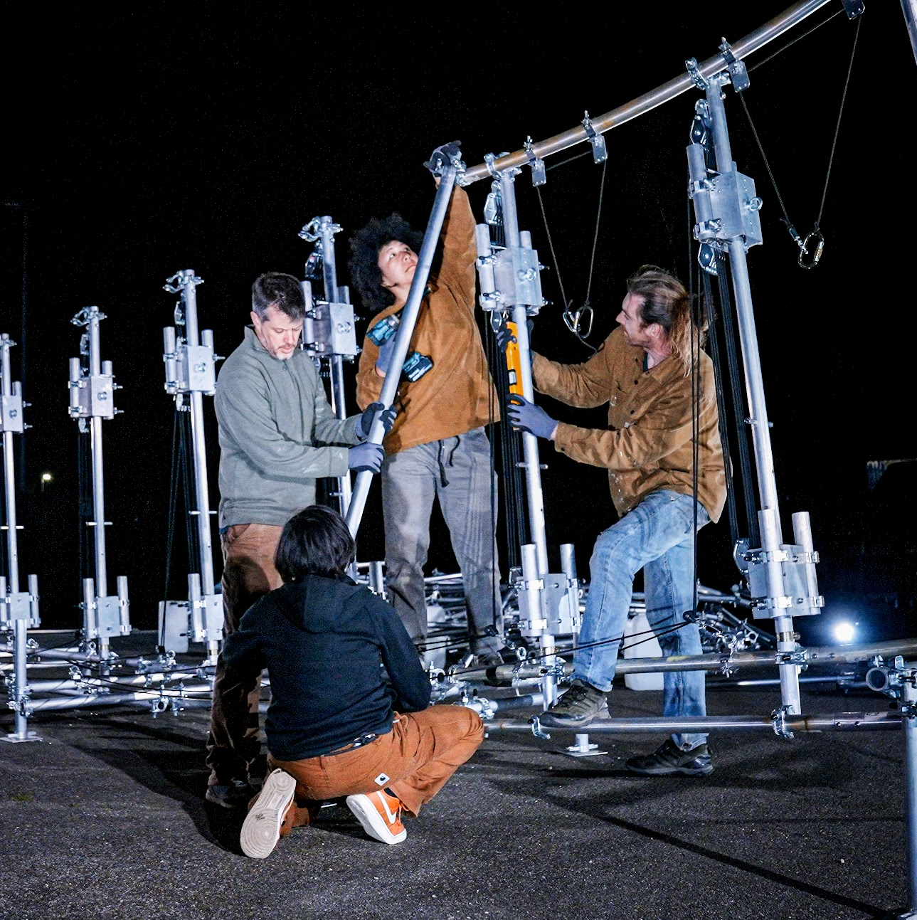 | Four people start building a sculpture.
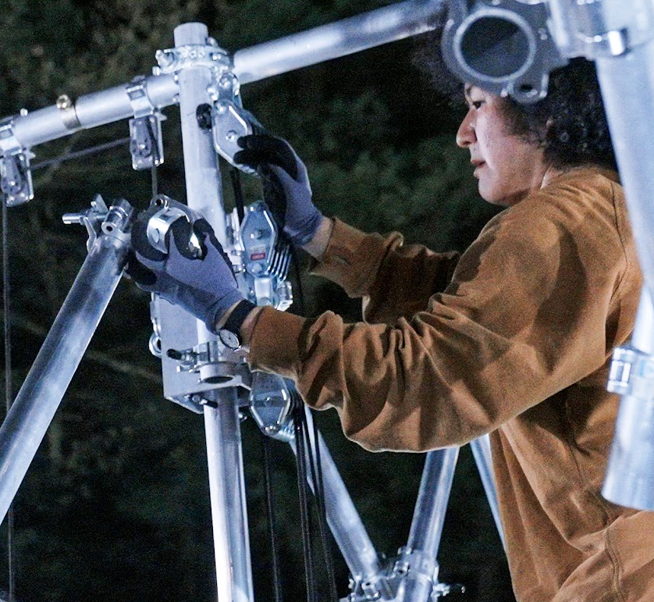 | They use metal tubes, clamps and different tools.
 | There is gentle vocal music.
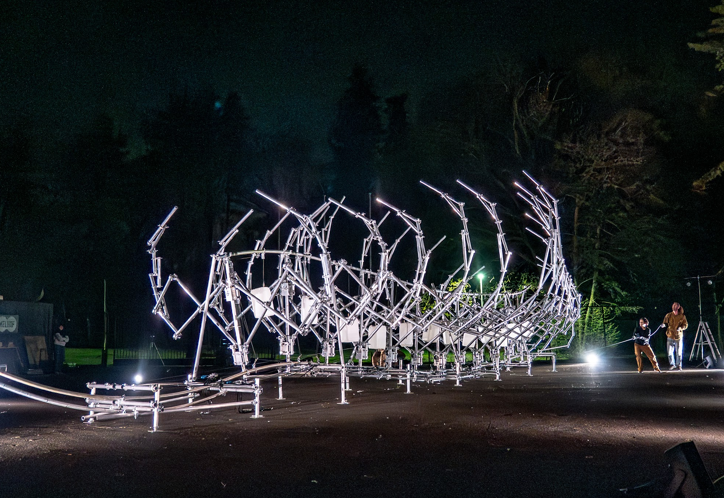 | The sculpture looks like bones of a giant ribcage.
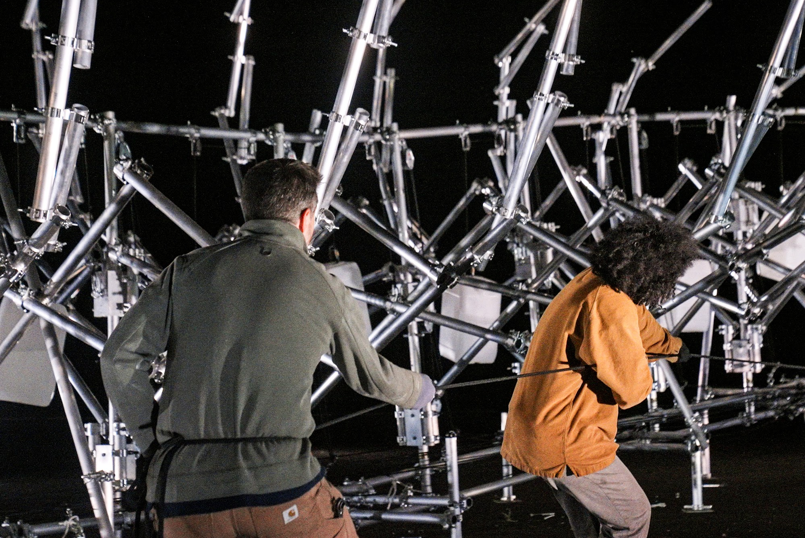 | Then, the people pull ropes.
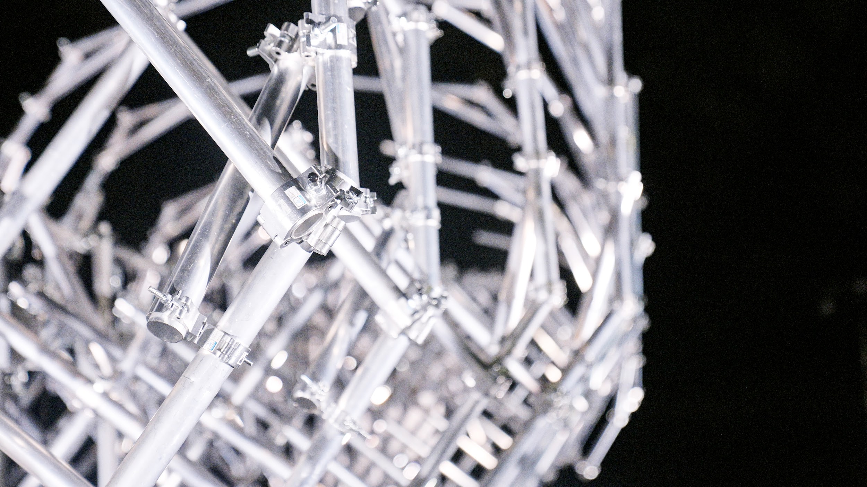 | The ribcage moves, like it is breathing.
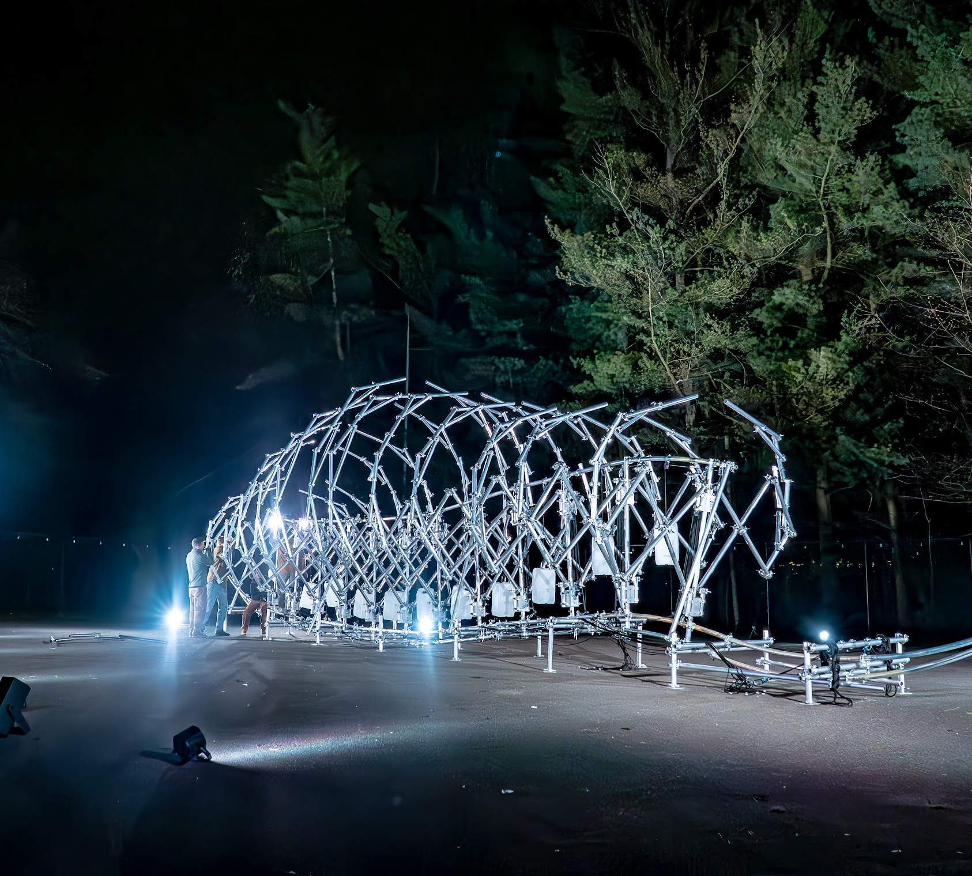 | Finally, it stops.
 | What is Requiem about?
 | Requiem is about our world and life in it.  The world is beautiful and amazing, like the sculpture.
 | Humans are part of the world, and help build it.
 | Humans can take care of the world.  We can make the sculpture breathe.
 | But life and breath also end.  We want to think about this, together.
 | What can I expect?
 | Requiem lasts about  1 hour 30 minutes.
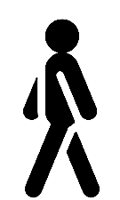 | You can stand, sit, or move around.
 | You can come and go whenever you want.
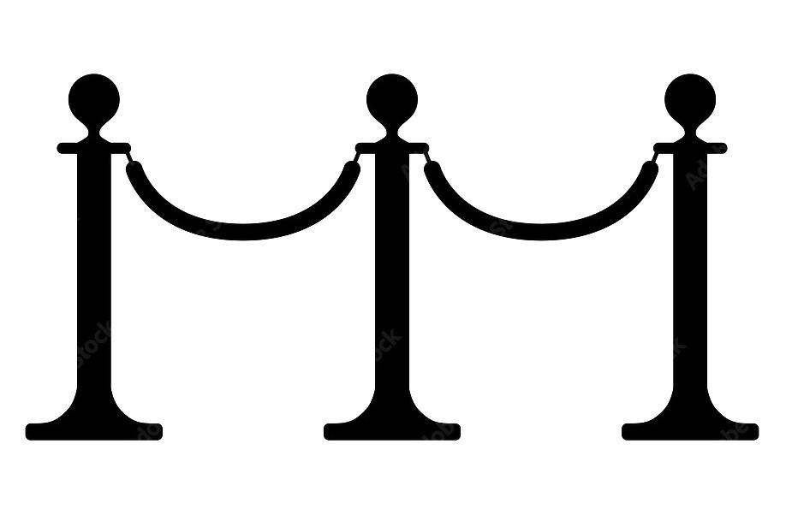 | Please stay behind the barrier.
 | Please do not touch the sculpture.
 | There will be gentle music.
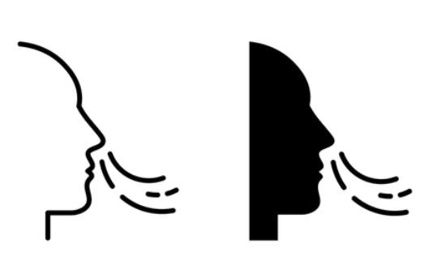 | There will be breathing sounds.
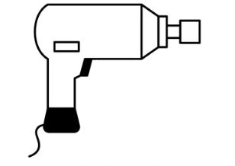 | The performers use tools, including impact drivers.  Sometimes there will be loud noises from those tools.
 | There will be lights pointed at the sculpture.

Requiem is an artwork by Kaleider
https://kaleider.com/portfolio/requiem/
https://kaleider.com

