Twist and Shine - Easy Read

 | What is Twist and Shine?
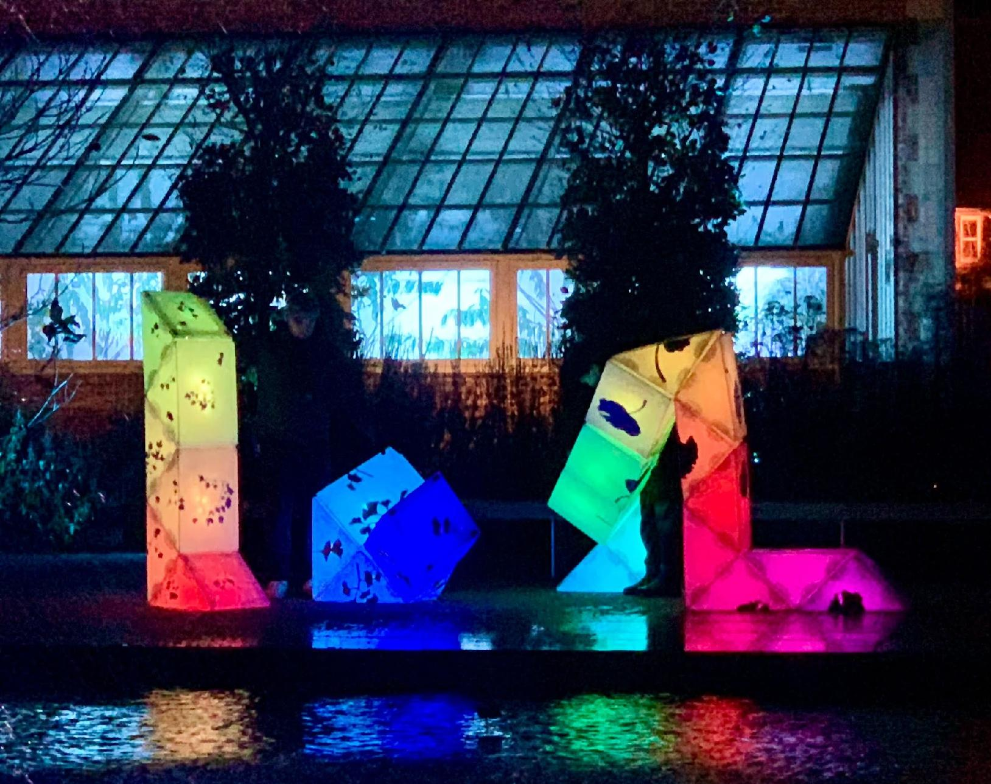 | Twist and Shine is a lot of big, glowing sculptures for playing.
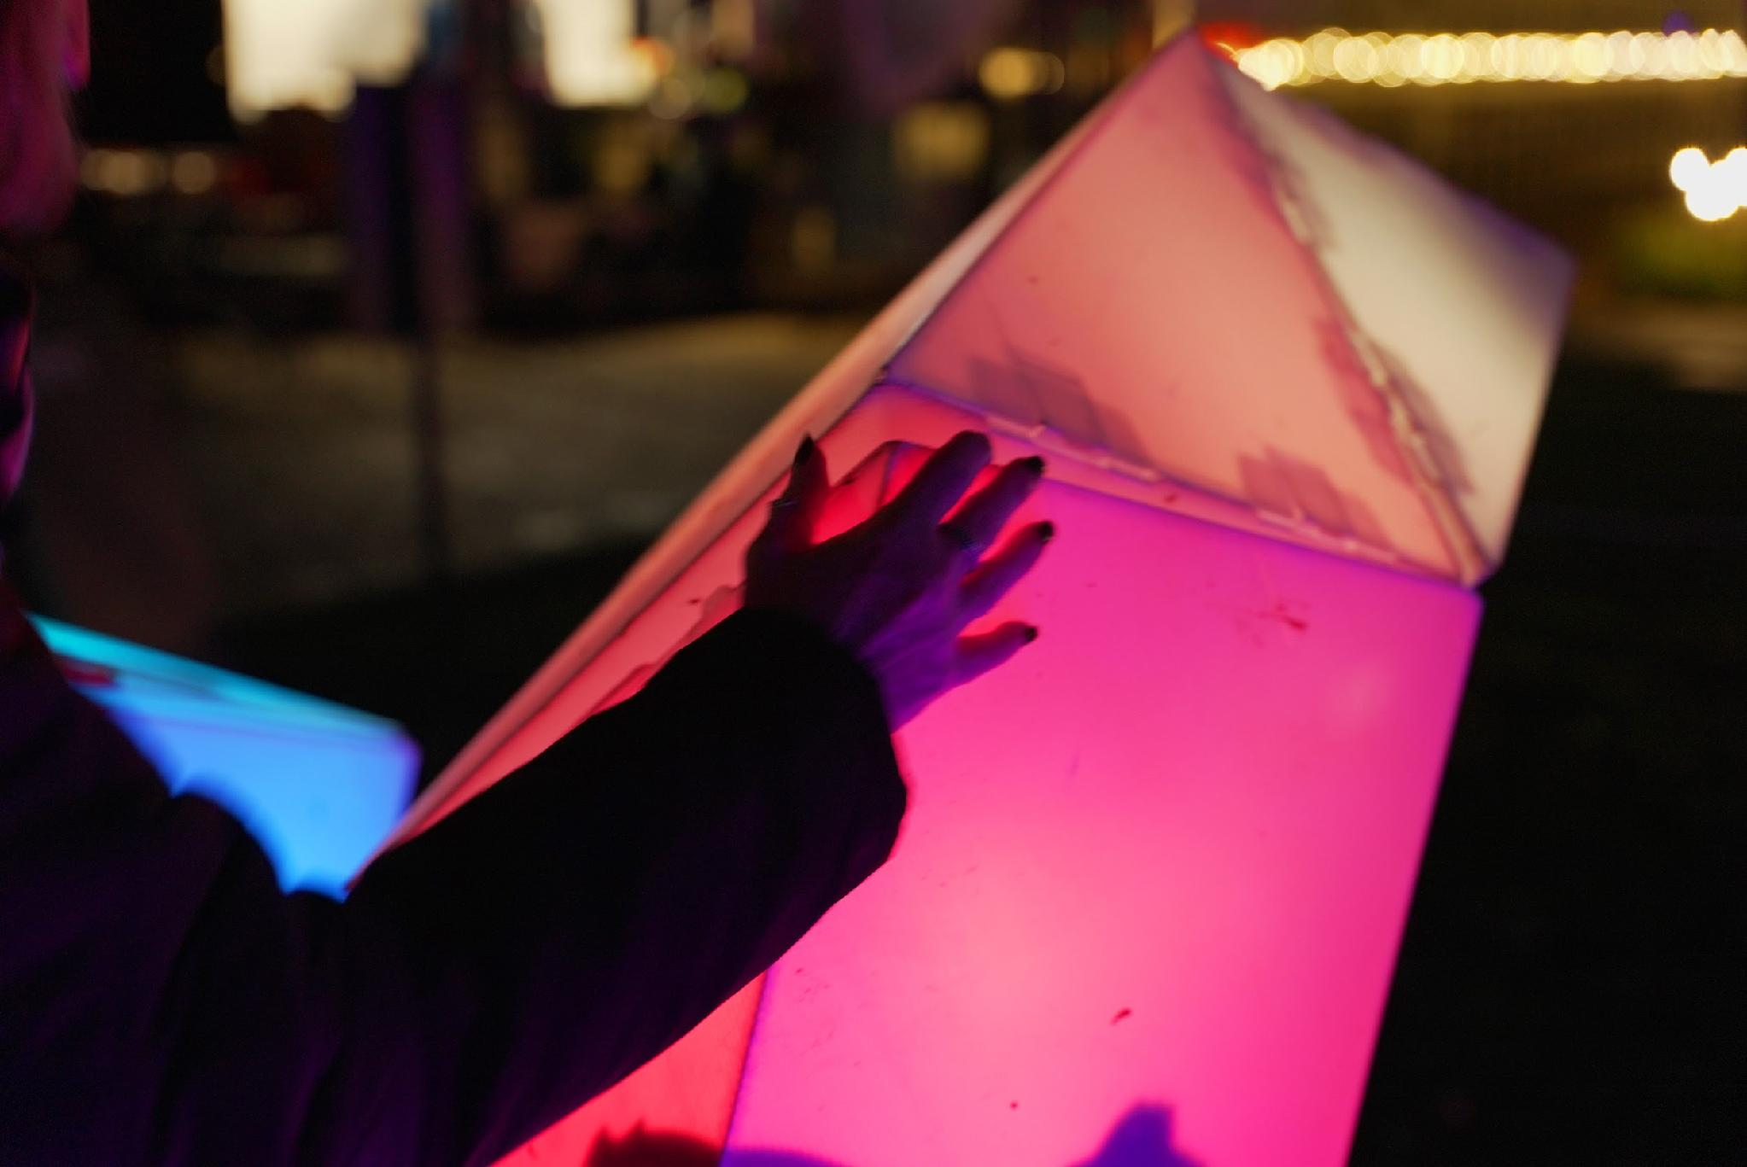 | The sculptures shine from the inside.
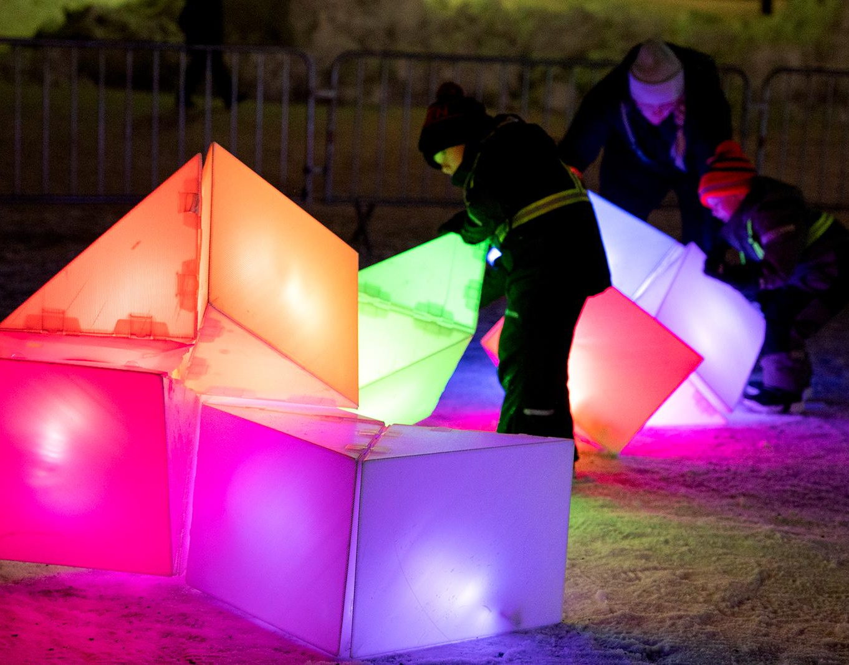 | Together, people can twist them.
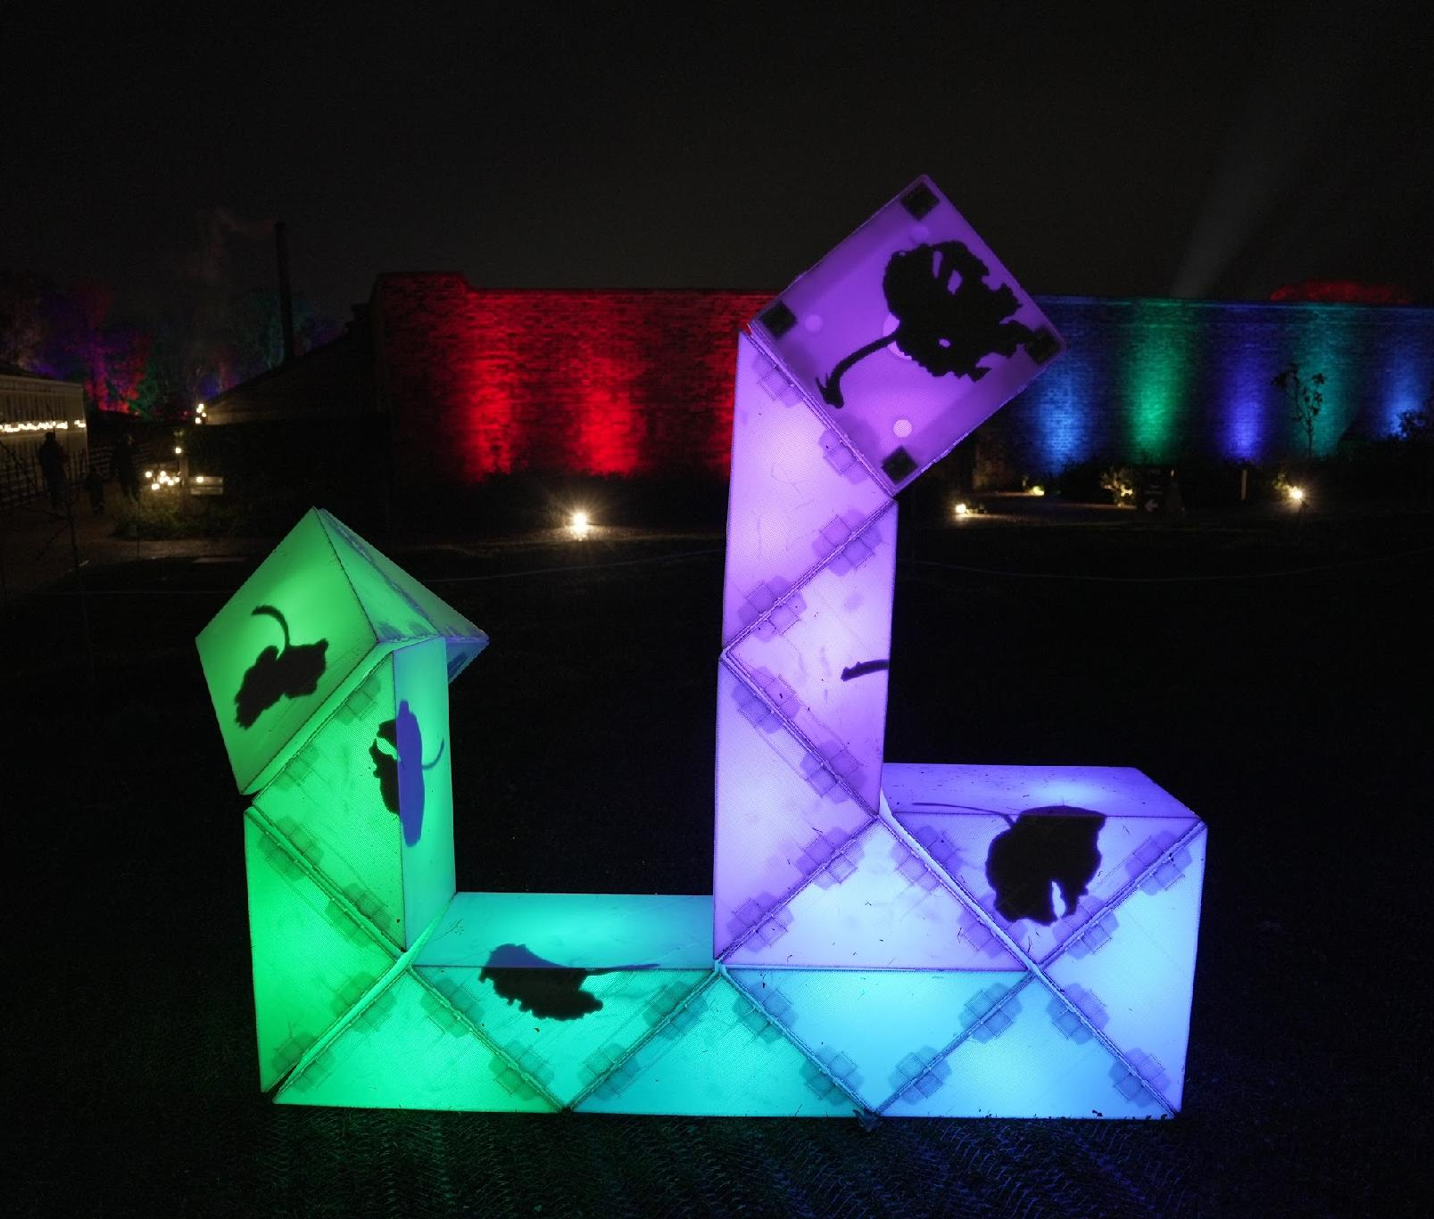  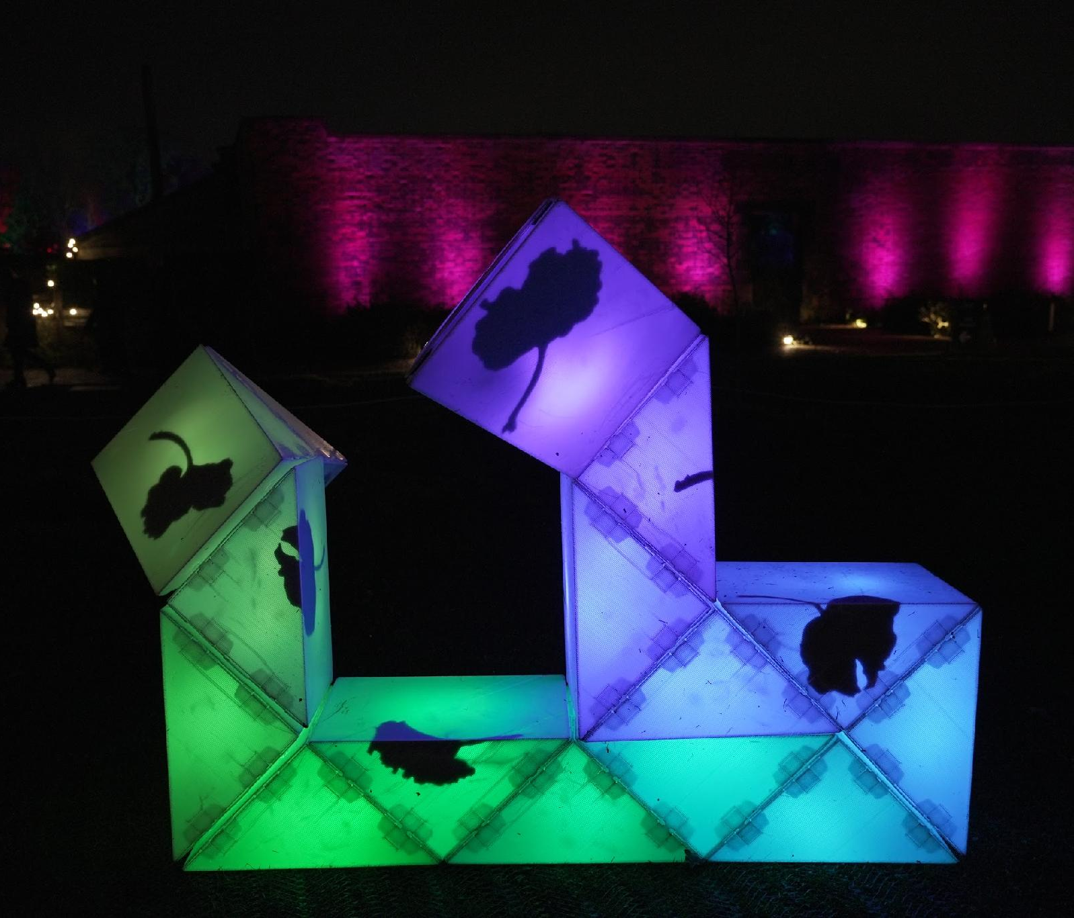 | When they twist, the shapes change.
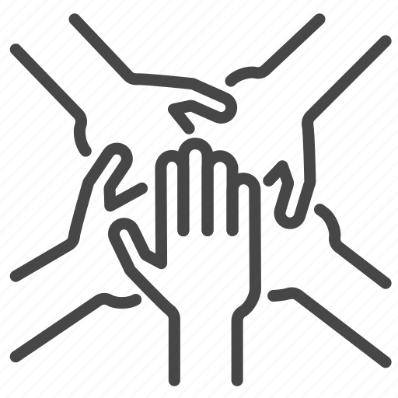 | It is for everyone to play with.
 | What can I expect?
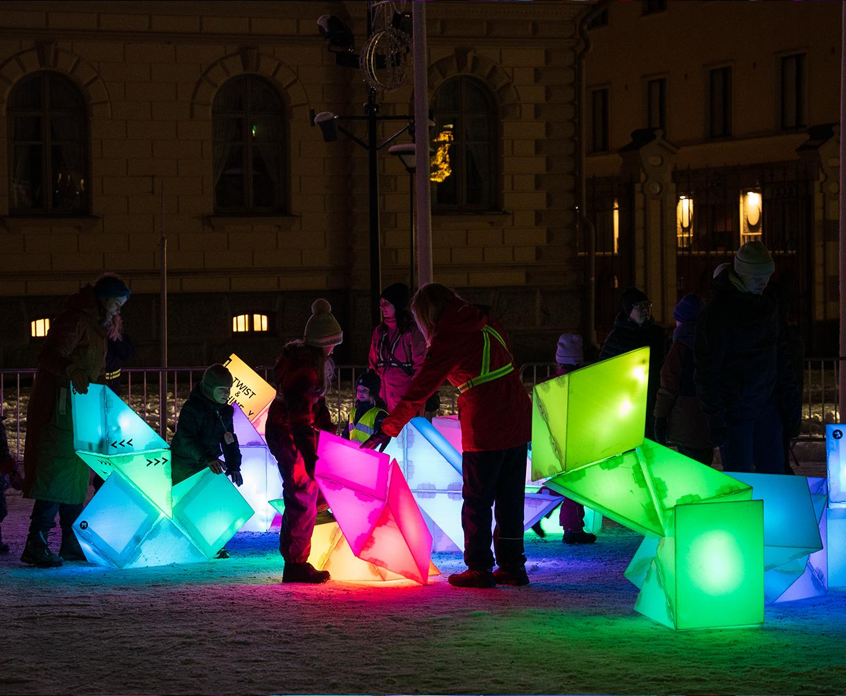 | You will arrive and find many big sculptures.
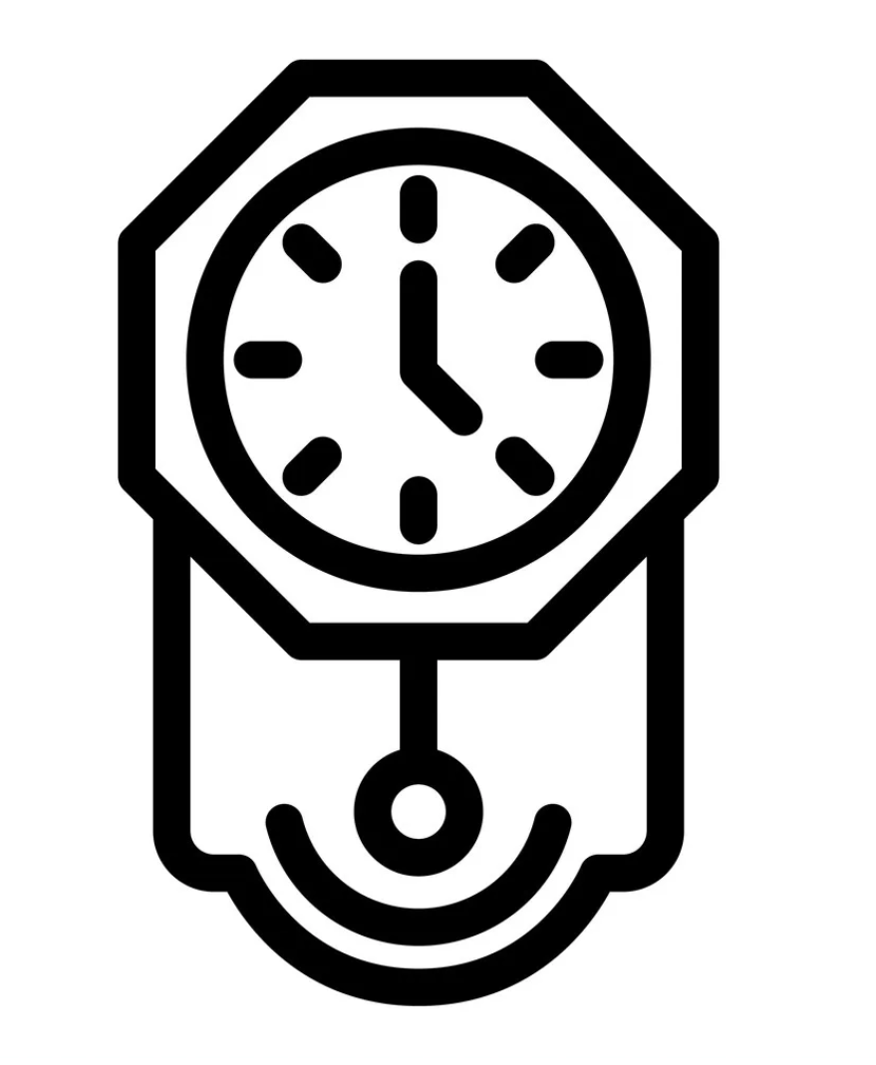 | You can look at them as long as you want.
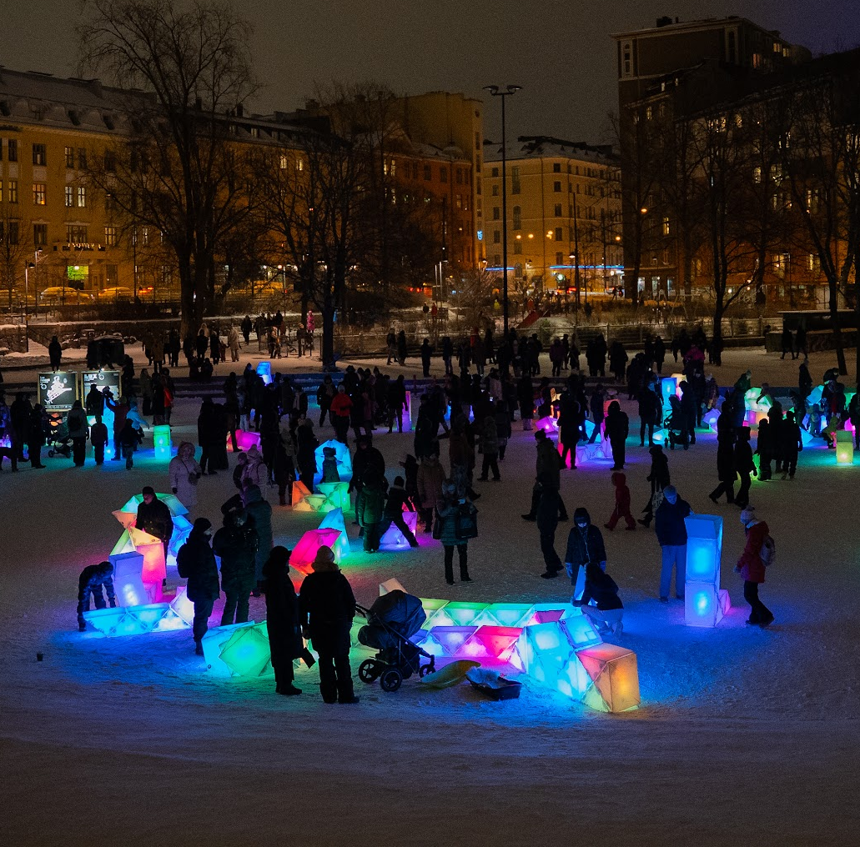 | You can watch other people play with the sculptures.
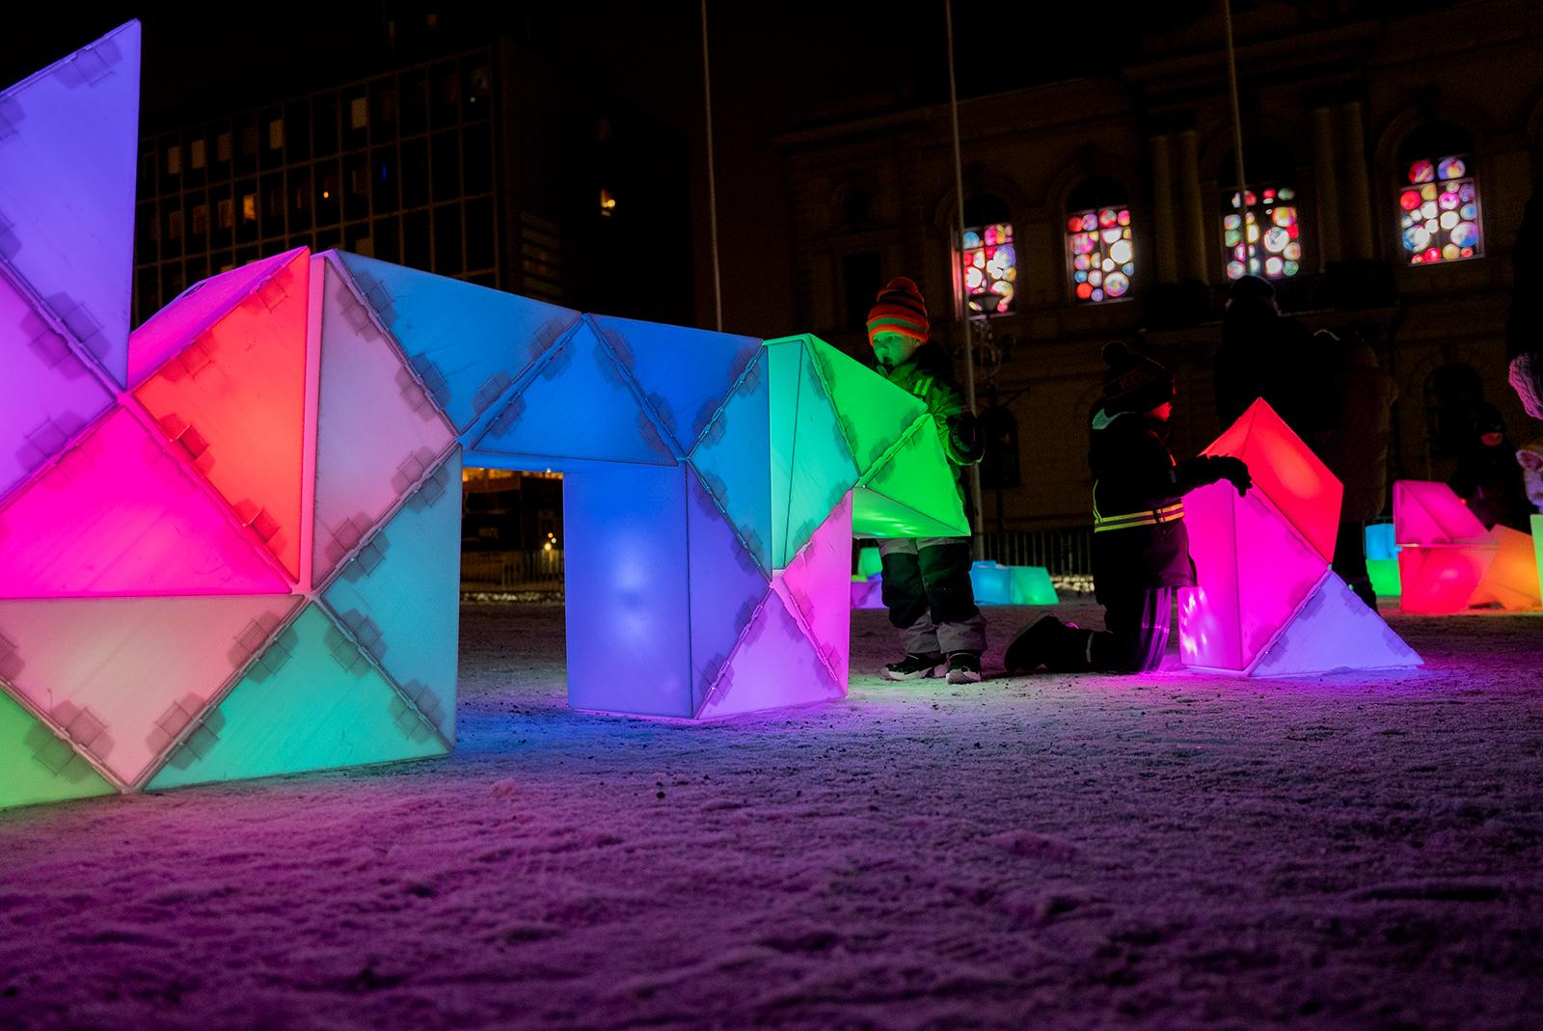 | Some sculptures are big.
 | Some sculptures are small.
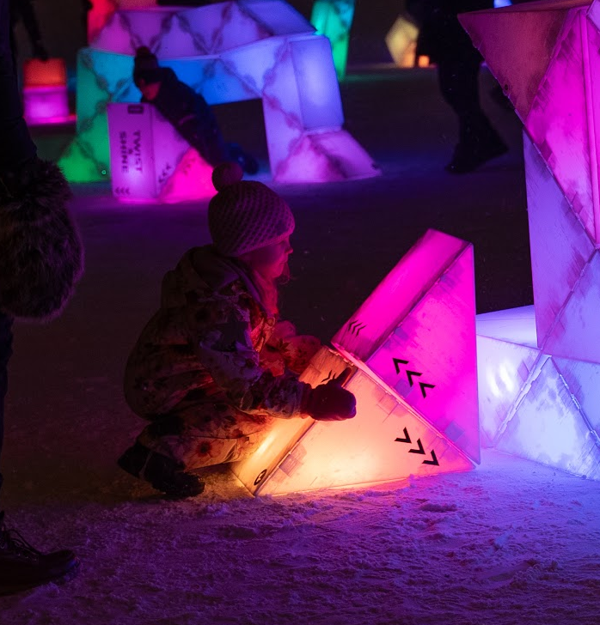 | You can try twisting smaller sculptures first.
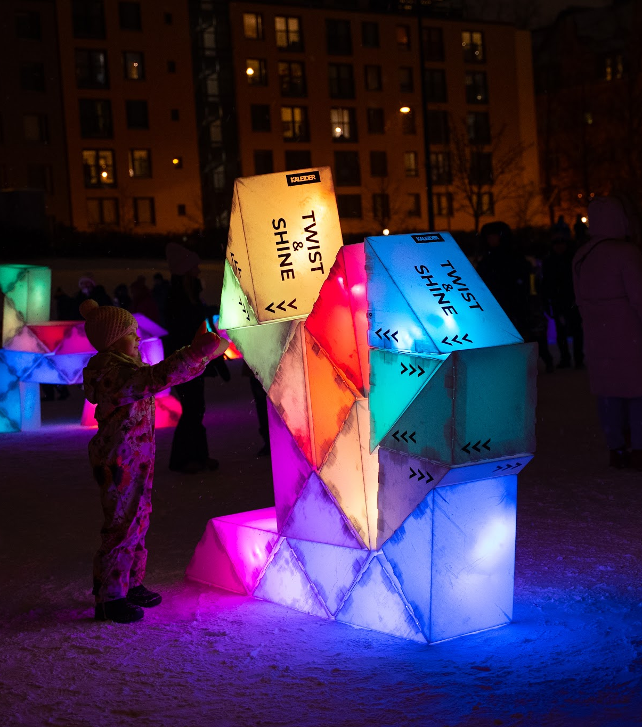 | When you are ready, you can go up to a big sculpture.
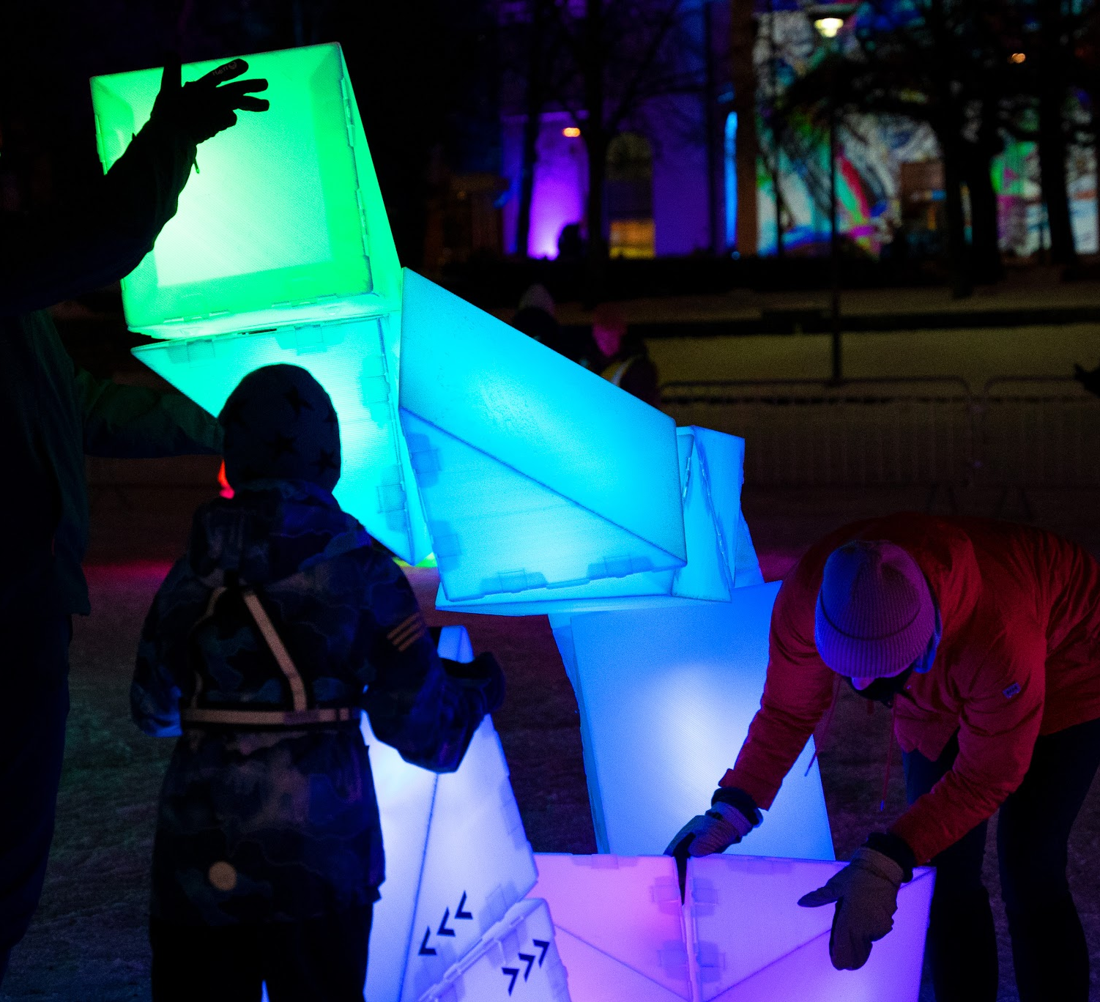 | Join a group, or ask people to help you.
 | Please twist gently.
 | Please pay attention to volunteers.
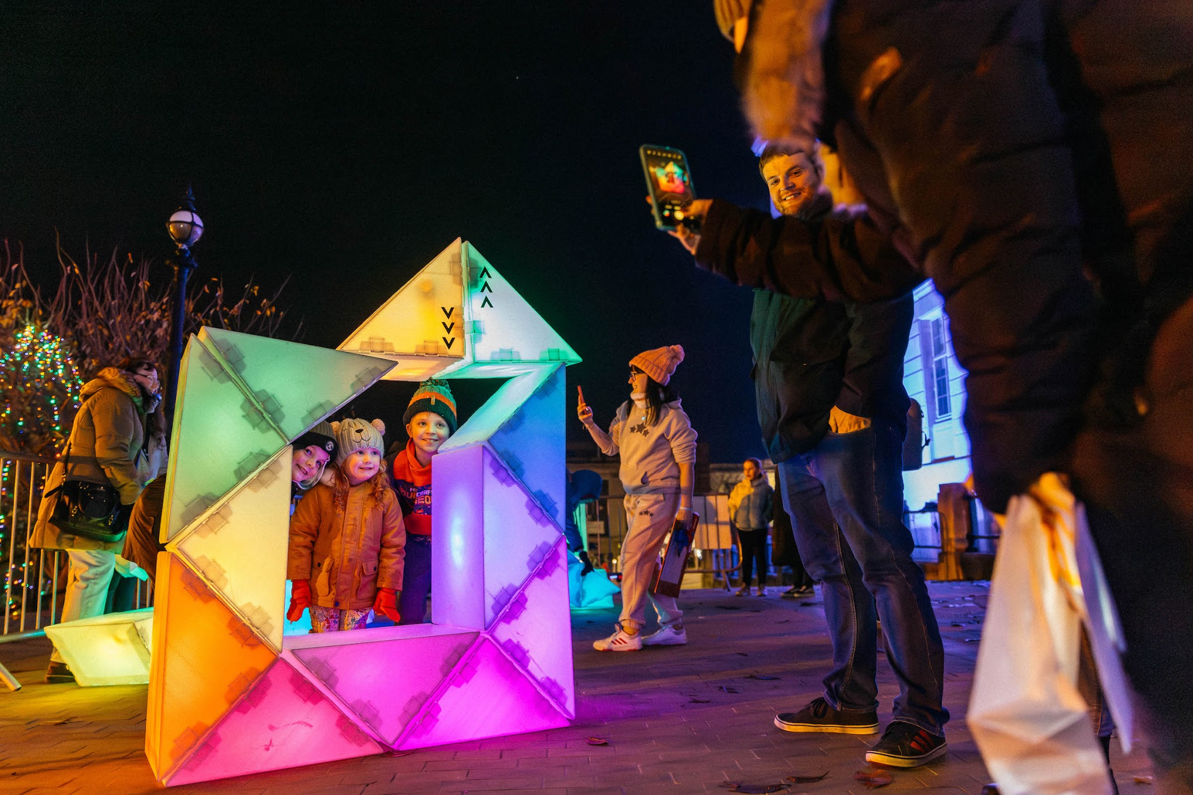 | Happy with your shape?
 | You can take pictures of the shapes you make.
   | You can leave, or come back, whenever you want.
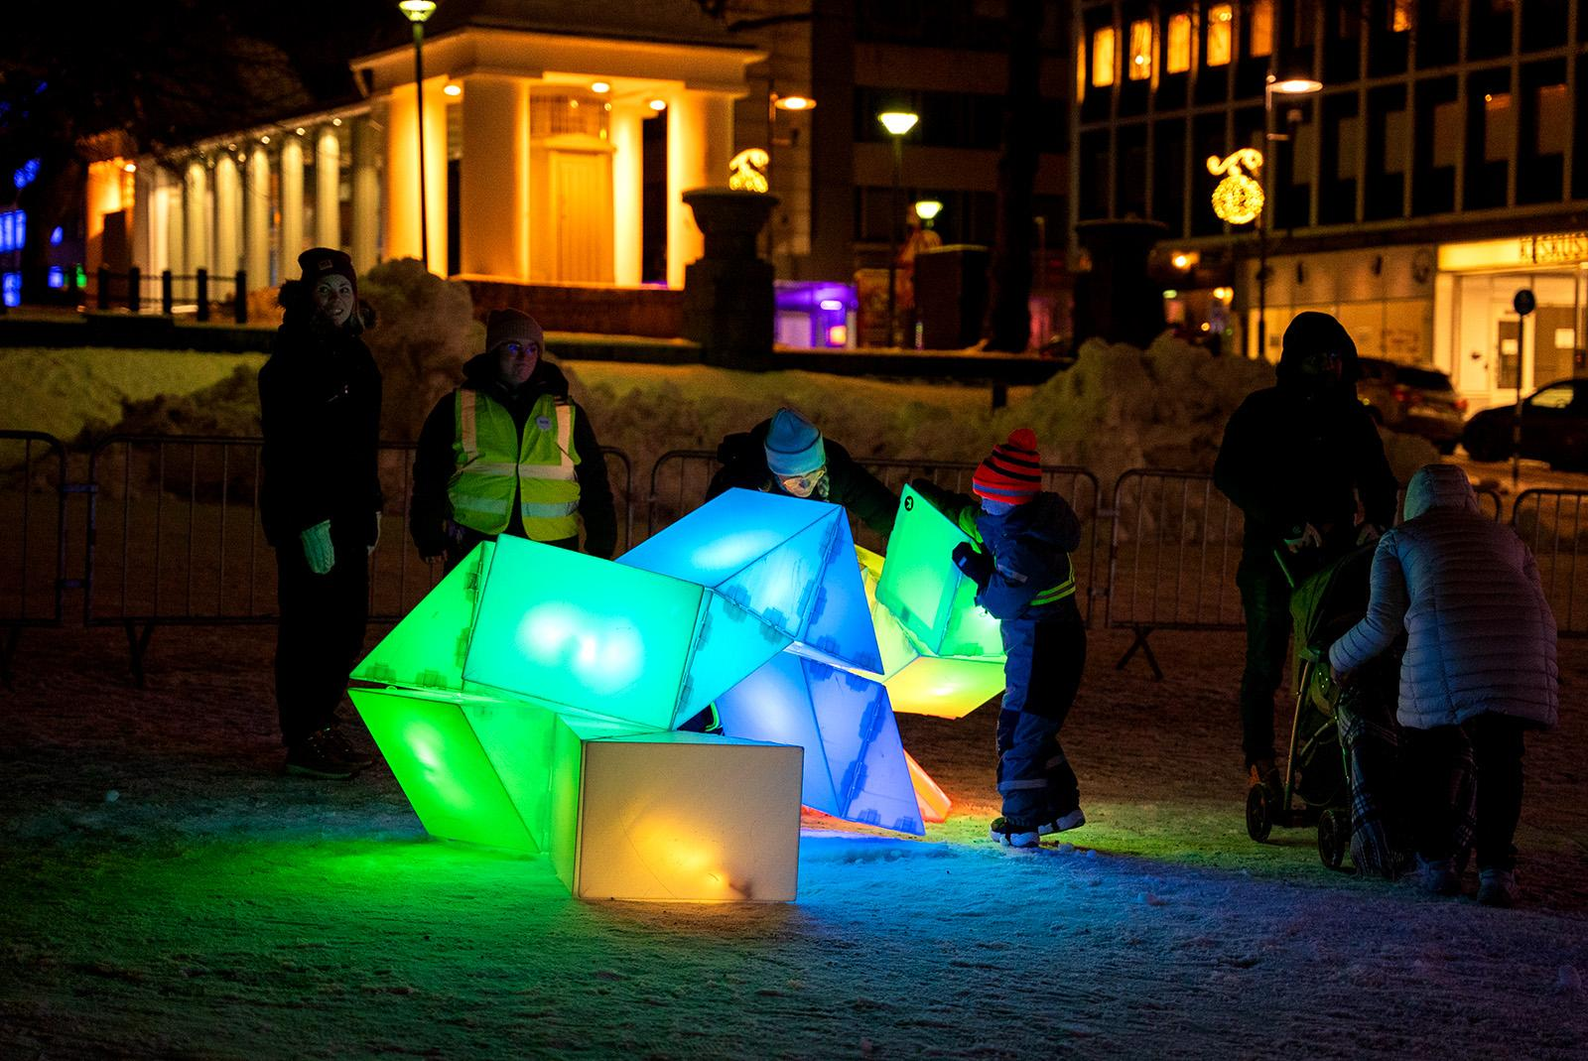 | Over time, the sculptures will change!
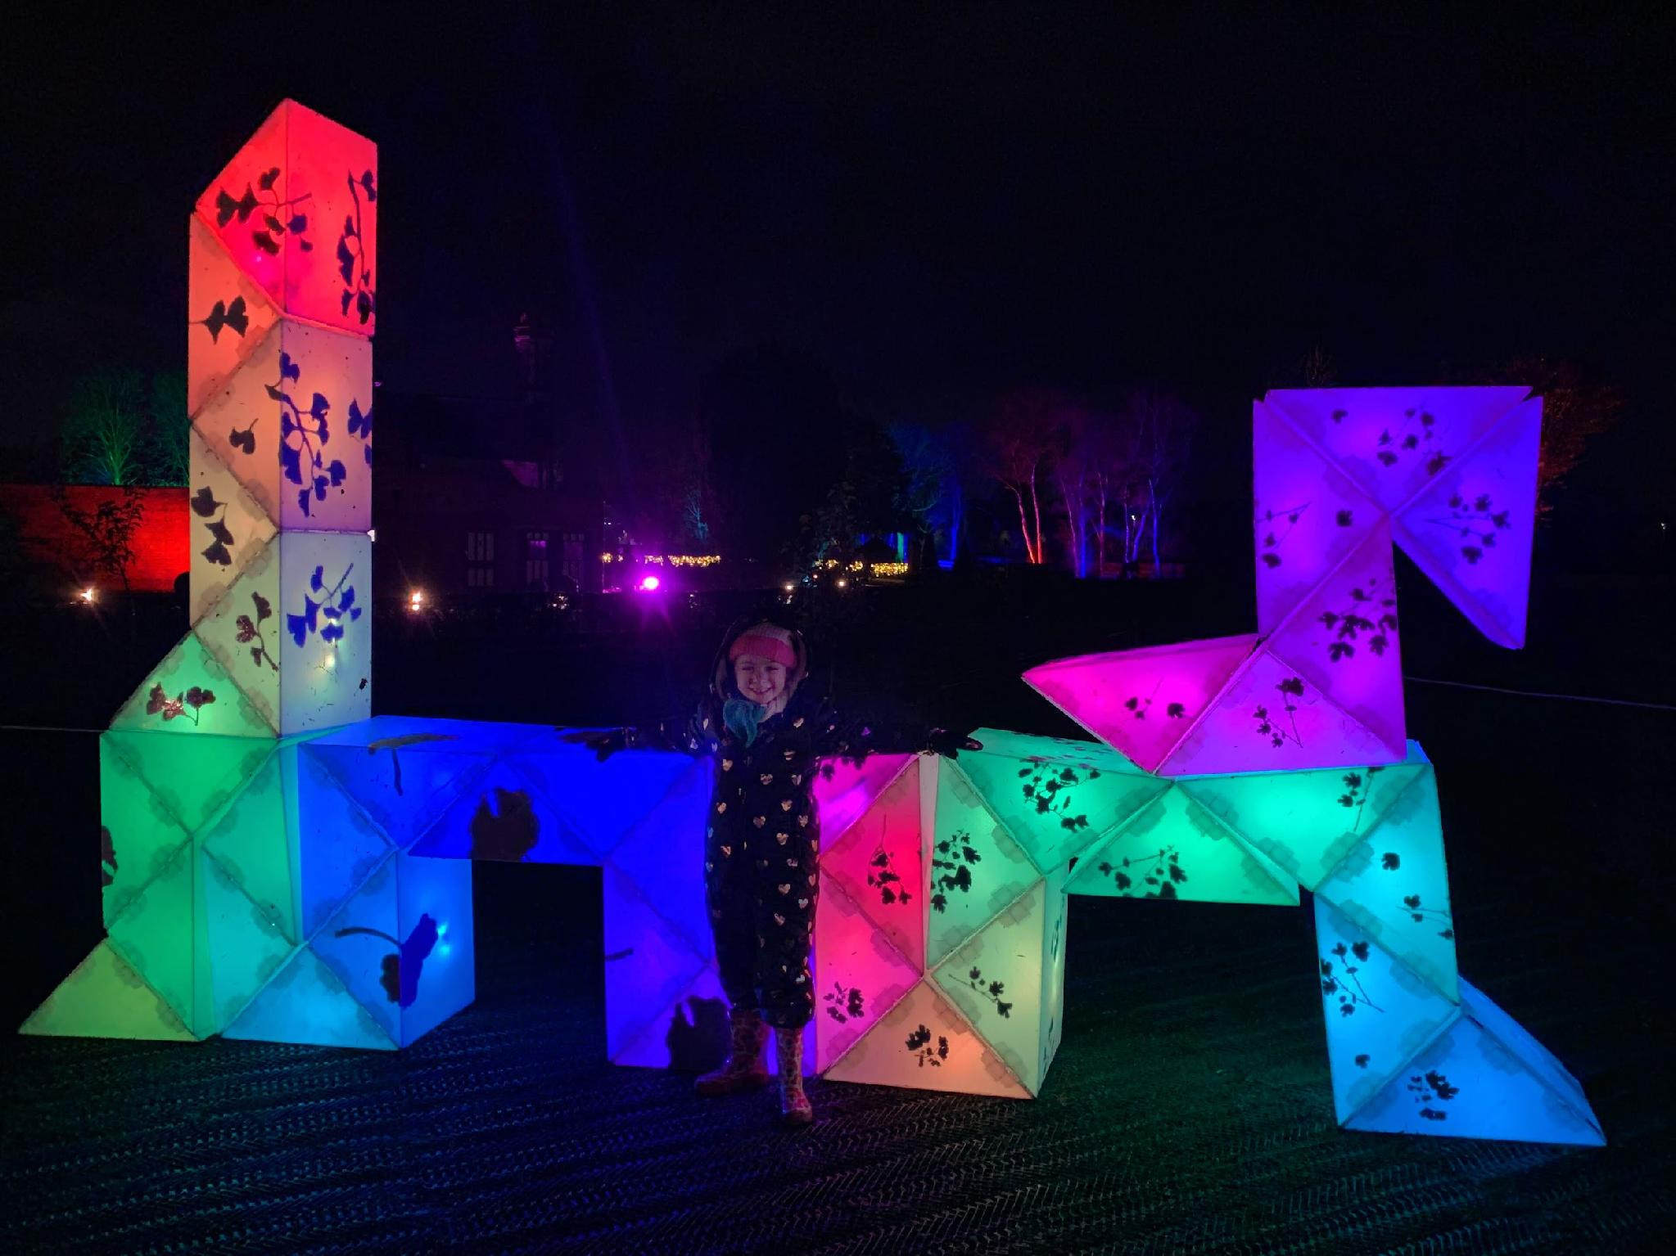 | Come back to see what other people make.

Twist and Shine is by Kaleider.
https://kaleider.com/portfolio/twist-and-shine/
https://kaleider.com

